ALL-PAIRS SHORTEST PATH ALGORITHM

- The all pair shortest path algorithm is also known as Floyd-Warshall algorithm is used to find all pair shortest path problem from a given weighted-directed graph.
- This algorithm will generate a matrix, which will represent the minimum distance from any node to all other nodes in the graph.
- At first the output matrix is same as given cost matrix of the graph.
- After that the output matrix will be updated with all vertices k as the intermediate vertex.
Floyd Warshall Algorithm

- We initialize the solution matrix same as the input graph matrix as a first step.
- Then we update the solution matrix by considering all vertices as an intermediate vertex.
- The idea is to one by one pick all vertices and updates all shortest paths which include the picked vertex as an intermediate vertex in the shortest path.
- When we pick vertex number k as an intermediate vertex, we already have considered vertices {0, 1, 2... k-1} as intermediate vertices.
- For every pair (i, j) of the source and destination vertices respectively, there are two possible cases.
1) k is not an intermediate vertex in shortest path from i to j. We keep the value of dist[i][j] as it is.
2) k is an intermediate vertex in shortest path from i to j.
- We update the value of dist[i][j] as dist[i][k] + dist[k][j] if dist[i][j] > dist[i][k] + dist[k][j]
Example

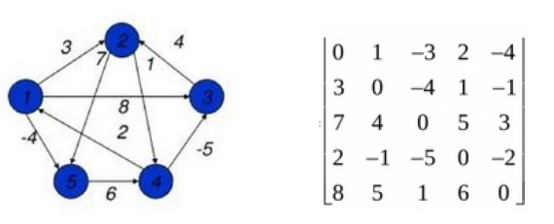
0 3 8 ∞ -4
∞ 0 ∞ 1 7
∞ 4 0 ∞ ∞
2 ∞ -5 0 ∞
∞ ∞ ∞ 6 0

D ^{[0]} =

D ^{[1]} -Find the shortest path between pair of vertices by using vertex 1 as the intermediate vertex.
0 3 8 ∞ -4
∞ 0 ∞ 1 7
∞ 4 0 ∞ ∞
2 5 -5 0 -2
∞ ∞ ∞ 6 0

D^{[1]}

0 3 8 4 -4
∞ 0 ∞ 1 7
∞ 4 0 5 11
2 5 -5 0 -2
∞ ∞ ∞ 6 0

D^{[2]}

D^{[3]}
0 3 8 4 -4
∞ 0 ∞ 1 7
∞ 4 0 5 11
2 -1 -5 0 -2
∞ ∞ ∞ 6 0

0 3 -1 4 -4
3 0 -4 1 -1
∞ 4 0 5 3
2 -1 -5 0 -2
8 5 1 6 0

D [4]

D^{[5]}
0 1 -3 2 -4
3 0 - 4 -5 -5
7 4 0 5 3
2 -1 -5 0 -2
8 5 1 6 0

Algorithm Floyd-Warshall
Input − The cost matrix of given Graph.
Output − Matrix for shortest path between every pair of vertices
Floyd-Warshall (W)
- n ← rows [W]
- D ⁽⁰⁾ ← W
- for k ← 1 to n
- do for i ← 1 to n
- do for j ← 1 to n
- do d_{ij}^{(k)} ← min (d_{ij}^{(k-1)},d_{ik}^{(k-1)}+d_{kj}^{(k-1)} )

return D ^{(n)}

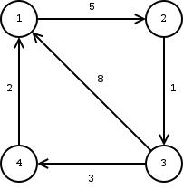
G(V,E)
Wij = 0 if i=j
Wij=Weight of the edge between i & j if (i,j) is an element of the edge set E
Wij=∞ if there is no edge between i & j
n=4
D(0)=W
K=1
D(1)

.

